FitBuddy- AI Fitness Plan Generator using Gemini Models

Project Description
FitBuddy is a web-based AI fitness application that creates personalized 7-day workout plans and practical nutrition or recovery guidance. It uses a user’s fitness goal, experience level, preferred intensity and other submitted information to shape the generated plan. Users can submit feedback to request adjustments, while an administrator can review saved users and plan records.
The application uses FastAPI for backend routing, Jinja2 templates for the browser interface, SQLite/SQLAlchemy for persistence, Pydantic for input validation, and Google Gemini models through the current Google Gen AI SDK. A demo/fallback mode supports local testing when live AI generation is not configured.

Scenarios
- Scenario 1: Personalized workout generation
A user enters the requested profile and fitness details. The application validates the data and produces a structured 7-day plan with daily focus, warm-up, workout, rest and cooldown guidance.
- Scenario 2: Feedback-based plan revision
A user submits feedback such as requesting easier exercises, longer rest or additional cardio. The application uses the existing plan and feedback to create and store a revised plan.
- Scenario 3: Nutrition or recovery guidance
The application provides a concise goal-related tip to complement the workout schedule.
- Scenario 4: Administrator review
An administrator opens the users dashboard to review stored user details and available original or updated plans.

Technical Architecture
FitBuddy follows a modular, request-and-response architecture:
Layer | Technology | Purpose
User interface | HTML, CSS, JavaScript, Jinja2 | Collects profile details and displays plans, tips and feedback controls.
Application backend | FastAPI | Handles page routes, API endpoints, validation and response rendering.
Validation | Pydantic | Checks and structures incoming user and feedback data.
AI services | Google Gen AI SDK / Gemini | Generates workout plans, nutrition tips and feedback revisions.
Persistence | SQLite and SQLAlchemy | Stores user records and workout-plan information.
Local server | Uvicorn | Runs the ASGI application during development.

Application Request Flow
Browser form / API request
|
v
FastAPI route handler
|
+--> Pydantic validation
|
+--> AI service (Gemini or demo fallback)
|
+--> SQLite database (save / retrieve)
|
v
Jinja2 HTML response or JSON API response

Pre-requisites
- Python 3 and pip installed
- Basic Python and FastAPI knowledge
- HTML, CSS, JavaScript and Jinja2 familiarity
- SQLite and SQLAlchemy basics
- Google Gemini API key for live AI mode
- VS Code or another Python editor
- Virtual environment and terminal usage

Project Workflow

Milestone 1. Model Selection and Architecture
This milestone establishes the application requirements, AI integration approach and local development environment.

Activity 1.1. Identify AI requirements and select the model
The AI component is expected to generate a readable 7-day workout schedule, provide short nutrition/recovery tips and revise an existing plan from user feedback. The application uses configurable Gemini model names and the Google Gen AI SDK. The selected model configuration is kept separate from route code so it can be changed without redesigning the frontend.
- Workout generation and feedback updates use the configured text-generation service.
- Nutrition guidance is requested as a short, goal-aligned response.
- Demo/fallback responses are available for local testing when live AI is disabled or unavailable.

Activity 1.2. Define the application architecture
The project is divided into application modules, templates, static assets and tests. Routes coordinate input validation, AI calls, database operations and template responses.

Activity 1.3. Set up the development environment
# From the project root in the VS Code terminal
python -m venv .venv
.venv\Scripts\Activate.ps1
python -m pip install -r requirements.txt
If PowerShell blocks activation, allow it for the current terminal session, then activate:
Set-ExecutionPolicy -Scope Process -ExecutionPolicy RemoteSigned
.\.venv\Scripts\Activate.ps1

Milestone 2. Core Functionalities Development

Activity 2.1. Develop the core functionalities

Workout plan generation
The AI service accepts validated user details and requests a structured weekly plan. The result is returned to the route for storage and display. The plan should be clear and practical, with warm-up, exercises, sets/repetitions or duration, rest and cooldown.

Nutrition tip generation
A separate service request produces a short nutrition or recovery tip related to the user’s stated goal. The tip is displayed with the plan.

Feedback-based plan updating
The update function combines the saved original plan with the user’s feedback. It requests a revised schedule and retains the original version for comparison.

User and plan storage
Database operations are kept in the database module. User data and generated plan versions are stored so that the result page and administrator view can retrieve them.

Activity 2.2. Implement backend input processing
FastAPI receives form or JSON data, validates it with Pydantic schemas, calls the appropriate service and returns an HTML template or JSON result. Error handling provides a useful response when an AI or database operation fails.

Milestone 3. routes.py Development

Activity 3.1. Implement the main route handlers
Route | Method / Role | Purpose
/ | GET | Render the home page and user input form.
/generate-workout | POST | Validate profile details, generate plan/tip, save results and render the result page.
/submit-feedback | POST | Accept feedback, retrieve the original plan, generate a revision and save it.
/view-all-users | GET | Render the administrator view of saved users and plans.
/health | GET | Return a simple service-health response.
/docs | GET | Open FastAPI’s interactive API documentation.

Example route pattern
The following is a compact illustration of the route-to-service pattern; names and schemas should match the corresponding files in the project.
@router.get("/")
def home(request: Request):
return templates.TemplateResponse(
"index.html",
{"request": request}
)
@router.get("/health")
def health():
return {"status": "ok"}

Milestone 4. Frontend Development

Activity 4.1. Design and develop the user interface
The home page presents the FitBuddy branding and form fields. The result page displays the user profile, original plan, nutrition tip and feedback form. The administrator page presents stored records. CSS provides layout, spacing, colors and responsive behavior; JavaScript may enhance client-side form feedback.

Activity 4.2. Create dynamic Jinja2 templates
Template / Asset | Responsibility
index.html | Collects user profile and fitness preferences.
result.html | Shows profile details, generated plan, tip and feedback input.
all_users.html | Shows stored user and plan information for administrators.
error.html | Displays a user-friendly error message when required.
static/css/style.css | Controls visual layout, typography, colors and responsiveness.
static/js/script.js | Optional browser-side interaction and form behavior.

Example Jinja2 form structure
<form action="/generate-workout" method="post">
<label for="name">Name</label>
<input id="name" name="name" required>
<label for="user_id">User ID</label>
<input id="user_id" name="user_id" required>
<label for="age">Age</label>
<input id="age" name="age" type="number" min="1" required>
<label for="weight">Weight (kg)</label>
<input id="weight" name="weight" type="number"
min="1" step="0.1" required>
<button type="submit">Generate 7-Day Plan</button>
</form>

Example template output
<h2>Your Workout Plan</h2>
<p>{{ user.name }} — {{ user.goal }}</p>
<pre>{{ workout_plan }}</pre>
<section class="nutrition-tip">
<h3>Nutrition Tip</h3>
<p>{{ nutrition_tip }}</p>
</section>

Milestone 5. Deployment

Activity 5.1. Prepare the application for local deployment
Open the project root folder in VS Code, select the project’s .venv Python interpreter and install dependencies from requirements.txt. Keep API keys in a local .env file and do not commit secrets to version control.
# Example .env settings
GEMINI_API_KEY=your_gemini_api_key_here
DEMO_MODE=true
A typical project structure is shown below. If the actual folder contains additional modules, retain those files and adjust imports consistently.
FitBuddy-AI/
├── app/
│ ├── __init__.py
│ ├── main.py
│ ├── config.py
│ ├── database.py
│ ├── schemas.py
│ ├── ai_service.py
│ ├── routes.py
│ ├── templates/
│ │ ├── index.html
│ │ ├── result.html
│ │ ├── all_users.html
│ │ └── error.html
│ └── static/
│ ├── css/
│ │ └── style.css
│ └── js/
│ └── script.js
├── tests/
│ ├── test_health.py
│ └── test_api_validation.py
├── .env
├── .env.example
├── .gitignore
└── requirements.txt

Example application entry point
from fastapi import FastAPI
from fastapi.staticfiles import StaticFiles
from app.routes import router
app = FastAPI(title="FitBuddy AI")
app.include_router(router)
app.mount(
"/static",
StaticFiles(directory="app/static"),
name="static"
)

Activity 5.2. Run and verify local deployment
# Run from the FitBuddy-AI project root
python -m uvicorn app.main:app --reload
Open http://127.0.0.1:8000 in a browser to view the application. Open http://127.0.0.1:8000/docs to inspect and test the API. Keep the terminal running while using the local site. If an Internal Server Error appears, check the traceback in the terminal first.

Exploring the Website’s Web Pages

Home page
The home page introduces FitBuddy and provides the form for entering the user’s name, user ID, age, weight, fitness goal and workout intensity or other supported preferences. Submitting the form sends the information to the backend for processing.

Personalized workout generation page
The result page summarizes the submitted profile and presents the generated 7-day plan in a readable format. Daily sections can include the workout focus, warm-up, exercise details, rest intervals and cooldown.

Nutrition / recovery tip
A short tip appears alongside or beneath the workout plan to reinforce practical nutrition, hydration or recovery habits.

Feedback page
The feedback form lets users describe requested changes, such as making the routine easier, increasing rest or adding variety. The submitted feedback is used to generate an updated plan.

Original and updated plan comparison
When an updated plan exists, the application can display the original and revised versions together, along with the feedback and a summary of the changes.

View all users page
The administrator view lists saved users and the workout-plan records available for each user. It supports review of profile data and the evolution from original to updated plan.

Conclusion
FitBuddy brings together an AI-assisted workout generator, nutrition or recovery tips, feedback-based plan revision, data persistence and an administrative view. FastAPI coordinates the application, Jinja2 renders the pages, SQLite/SQLAlchemy stores records, and Gemini provides text-generation support when configured. The modular structure makes the application suitable for continued development, testing and future enhancements. Fitness guidance is general information and is not a substitute for advice from a qualified healthcare professional.

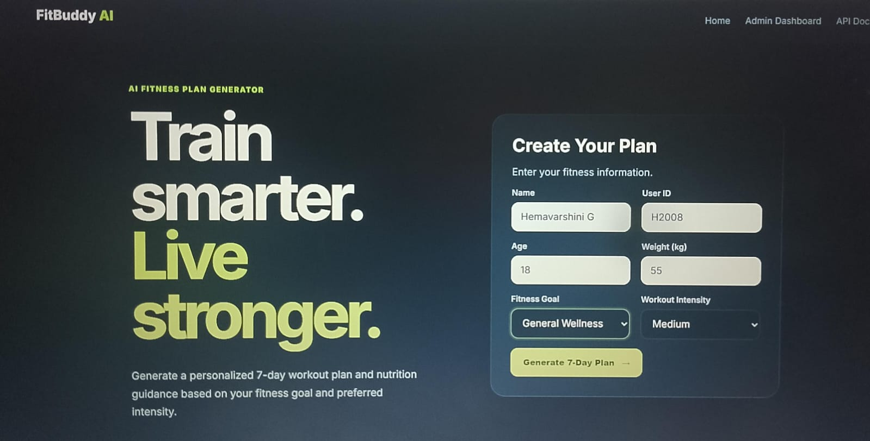
Figure 1. FitBuddy home page and fitness-plan input form.

Personalized workout generation page: User Information
Once the user submits their details, FitBuddy displays a summary of the user profile including name, user ID, age, weight, fitness goal, and selected intensity. This information guides the system in generating a workout plan tailored to the user's fitness preferences.
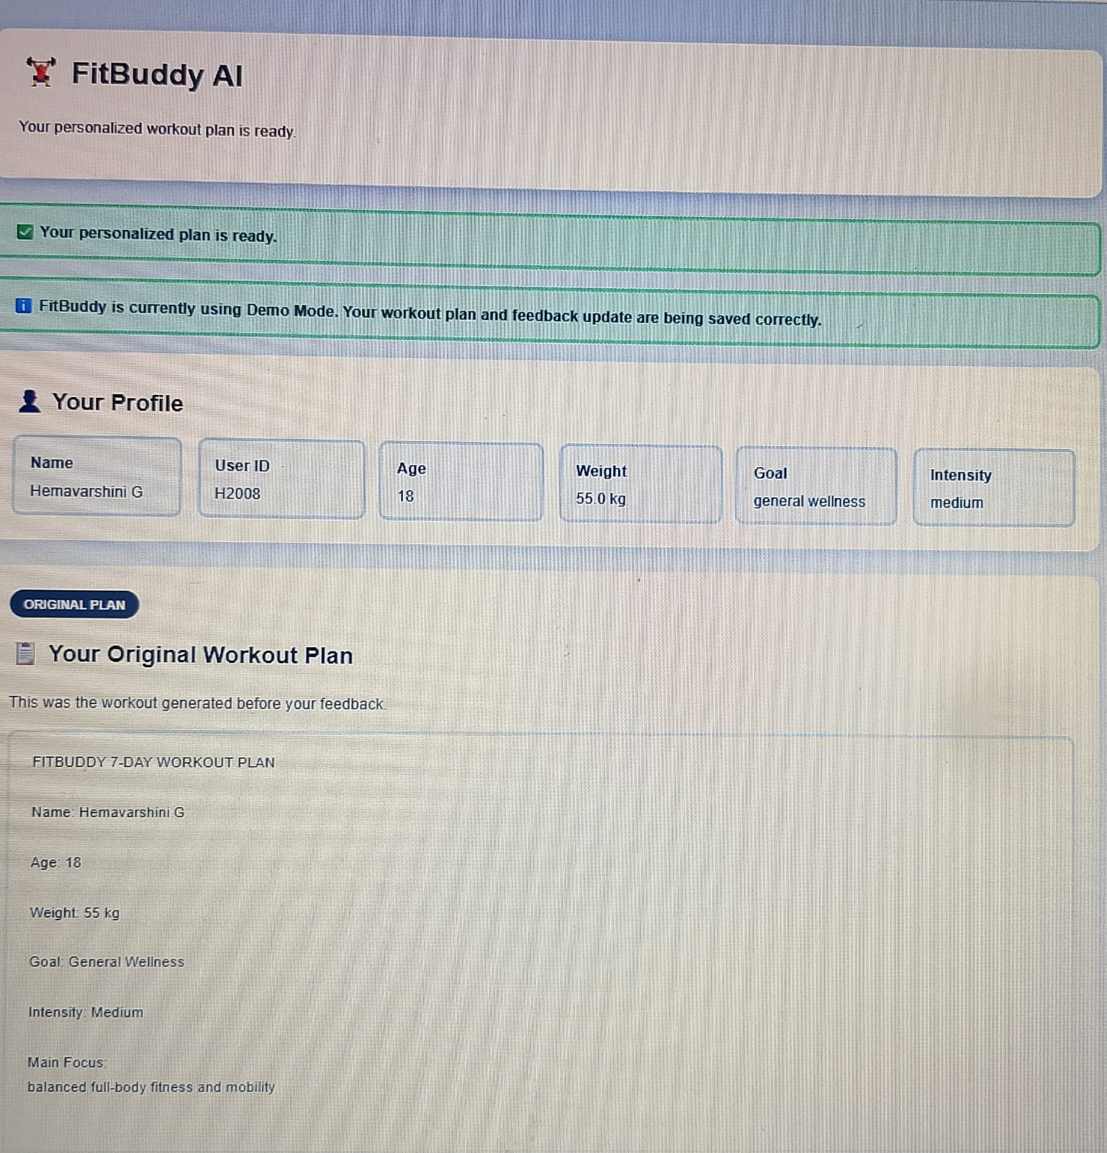
Figure 2. Generated-plan confirmation and user profile.

Workout Plan
FitBuddy generates a personalized, day-wise workout plan with daily focus, warm-up, exercise details, sets or repetitions, rest intervals, and cooldown guidance. The schedule is organized to make the routine clear and easy to follow.
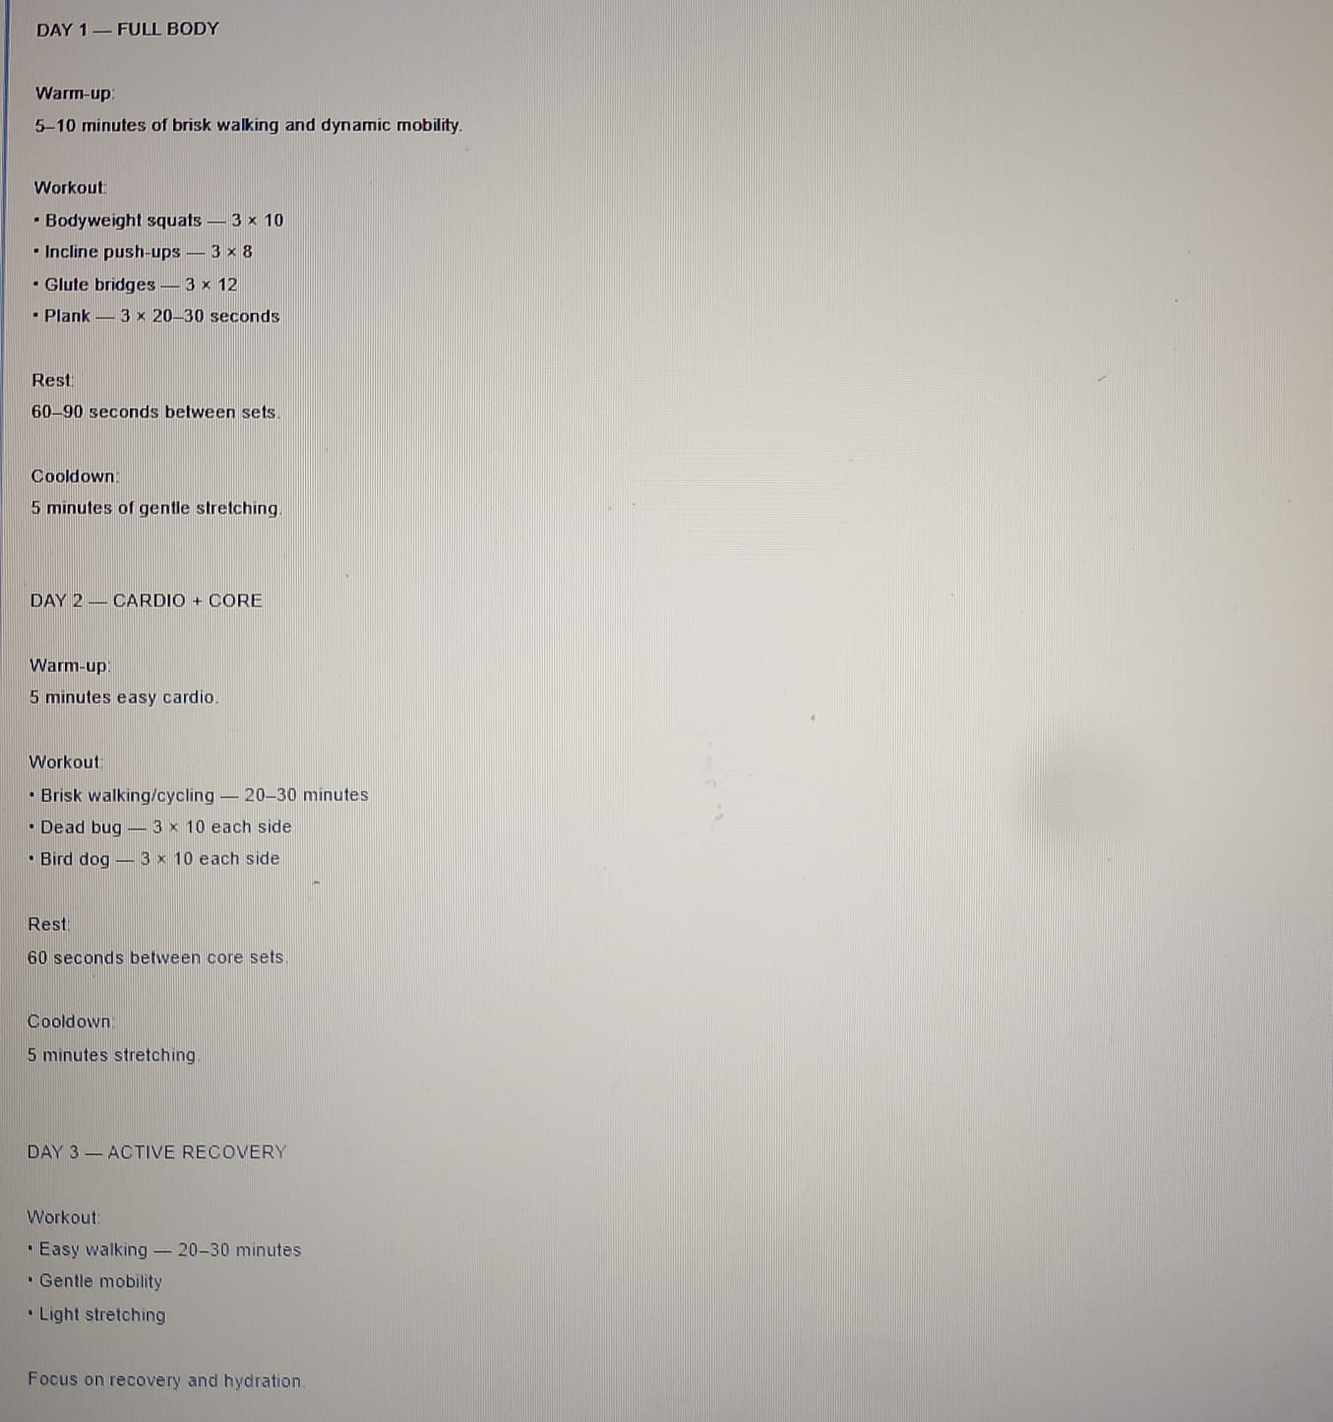
Figure 3. Original 7-day workout plan: first portion.

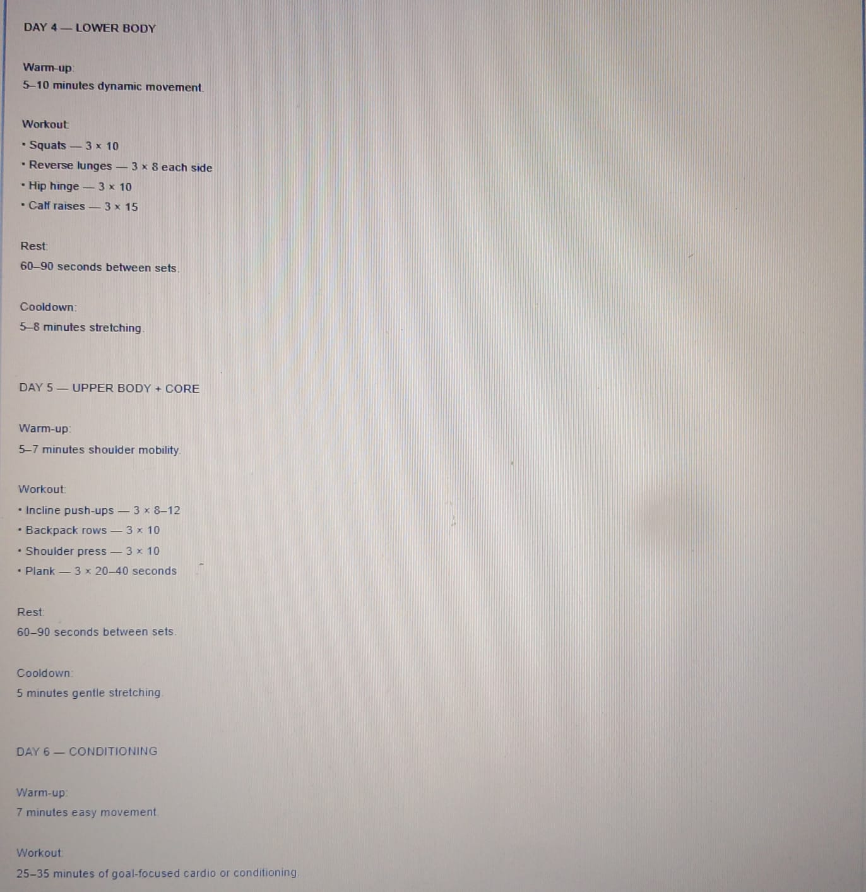
Figure 4. Original 7-day workout plan: continued schedule.

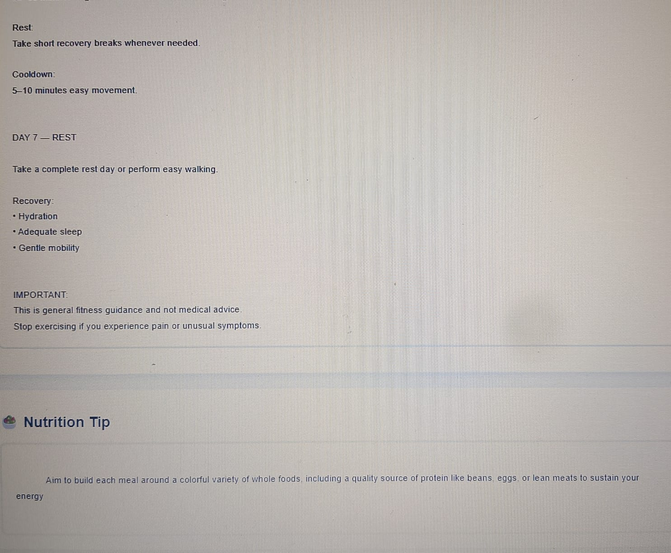
Figure 5. Rest, recovery and nutrition tip section.

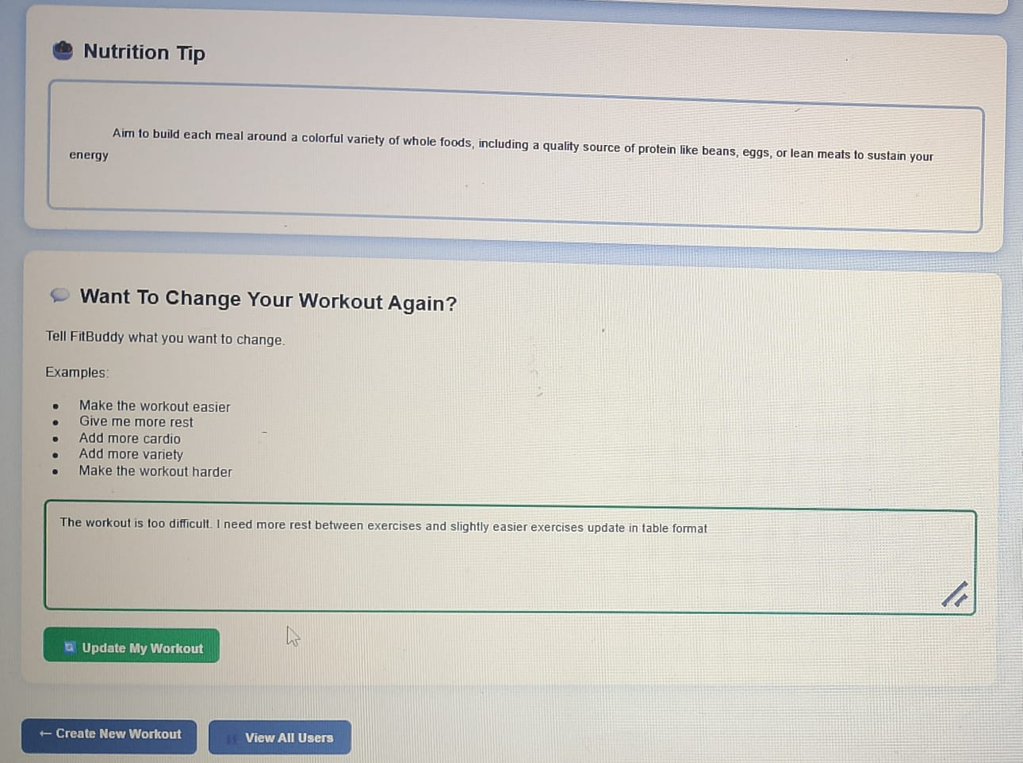
Figure 6. Feedback form for requesting workout changes.

